Department of Computer Engineering
University of Peradeniya
CO527 Advanced Database Systems
Edirimanna Y.H.
E/20/089
Q1) 1. Load data to each of the tables from the given .sql files. It should have the following mentioned number of records for each table if the import was successful.
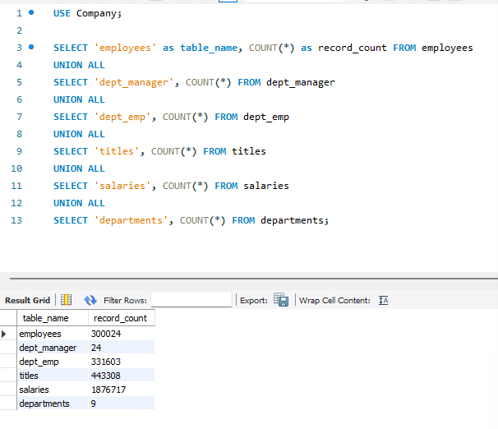

2. Find the top 10 family names(last_name) in the company.
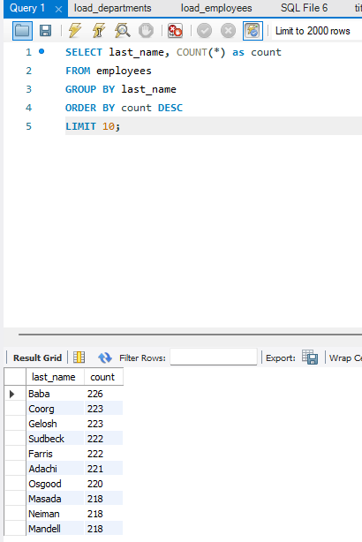

3. List the number of Engineers each department has.
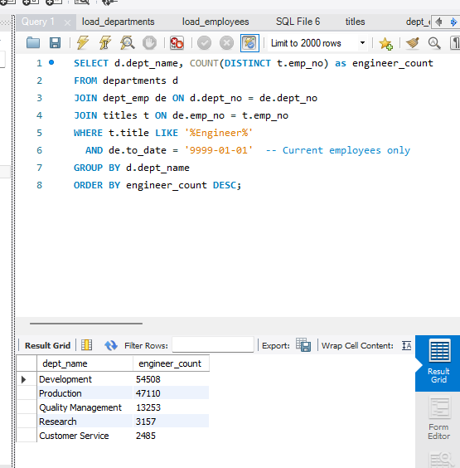
4. List all the female employees who are department managers and have worked as a senior engineer.
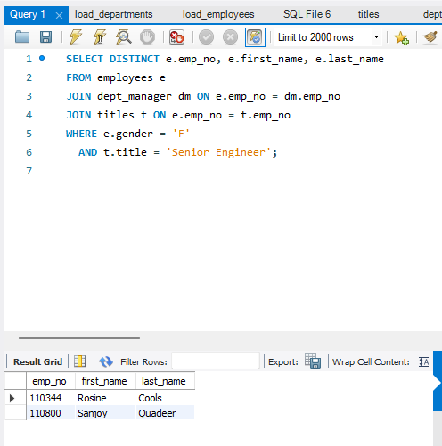
5. Display the departments and titles of employees who have a salary greater than 115000. Display how many of such employees work for each department.
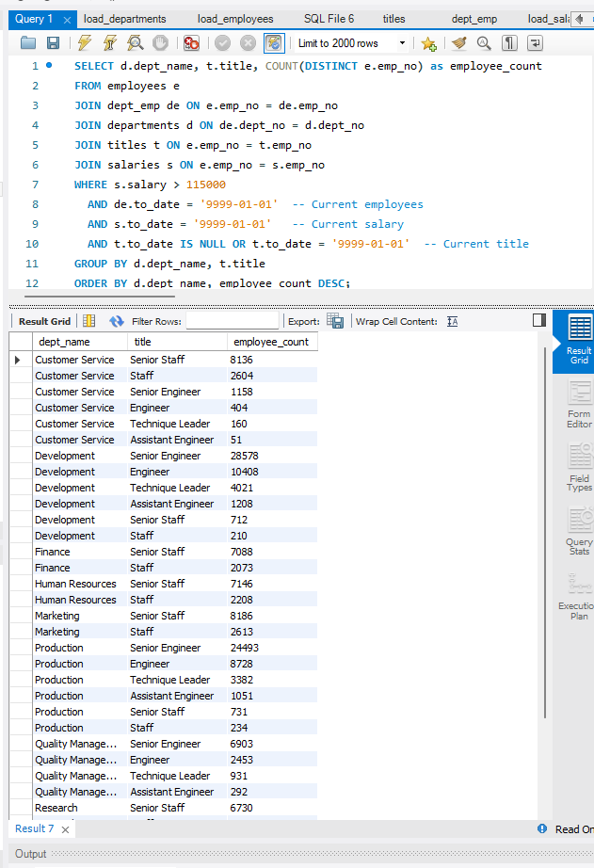
6. Assume that the company wants to reward the most senior employees who are more than 50 years of age and have contributed to the company for more than 10 years. Who is on the list? Display employee name, age, years of service in the company and joined date.
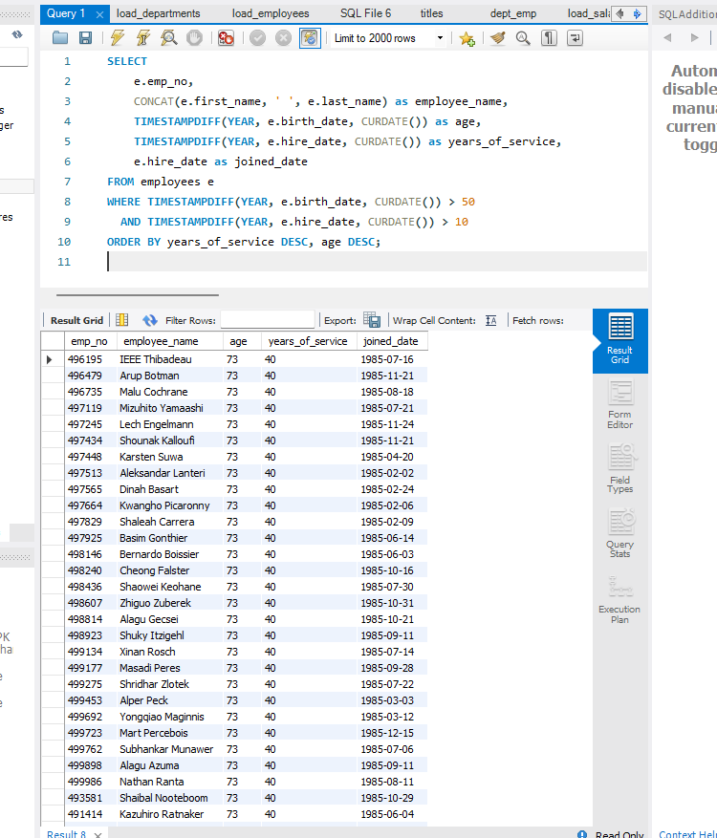
7. Find all the names (first name + last name) of employees in the database who do not work in the Human Resources department. Assume that all the people work for exactly one department.
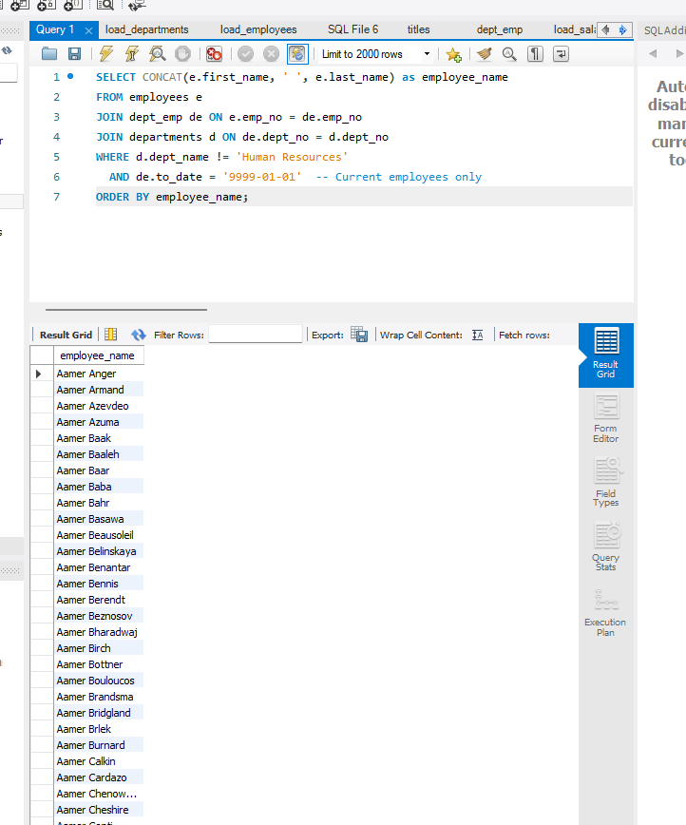
8. Find the names of all employees in the database who earn more than every employee in the Finance department. Assume that all people work for at most one company.
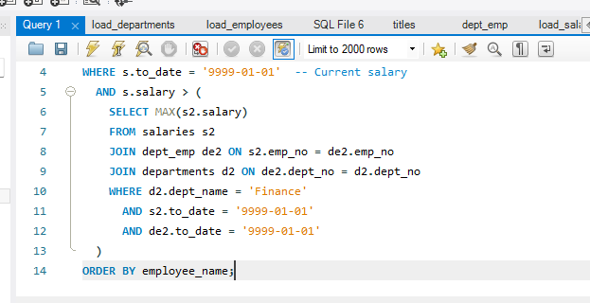
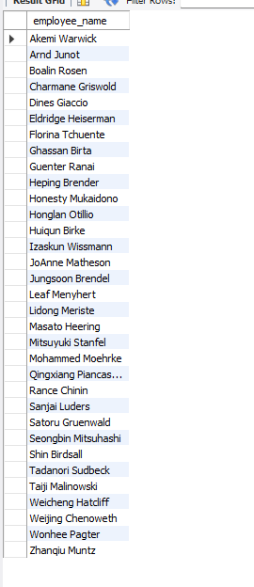
9. Find the names of all employees who earn more than the average salary of all employees of their company.
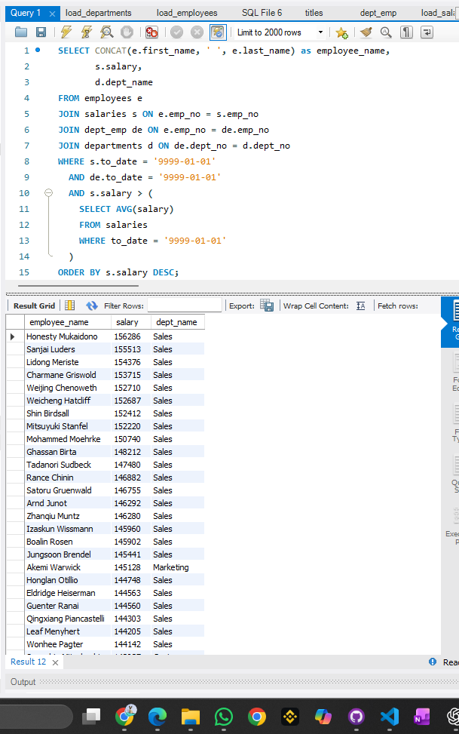
10. Compute the difference between the average salary of a Senior Engineer and the average salary of all employees (including Senior Engineers).
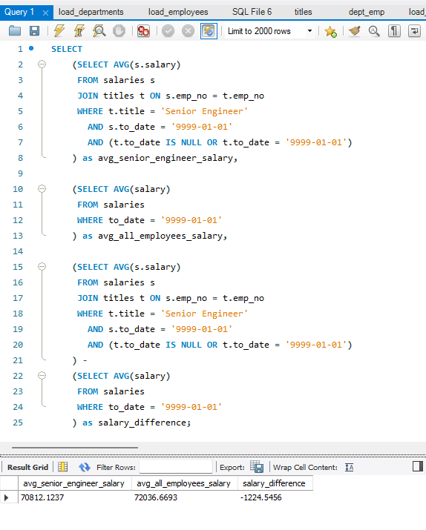
11. Create a view current dept emp (emp no, fromdate, todate) to show only the current department for each employee. You may have to use two views for this.
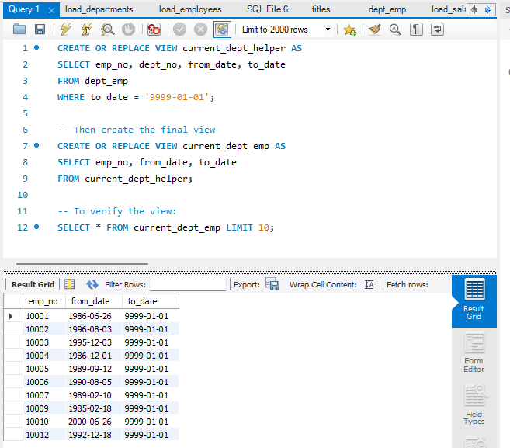

12. Write a normal SQL query to do the above task in problem 11.
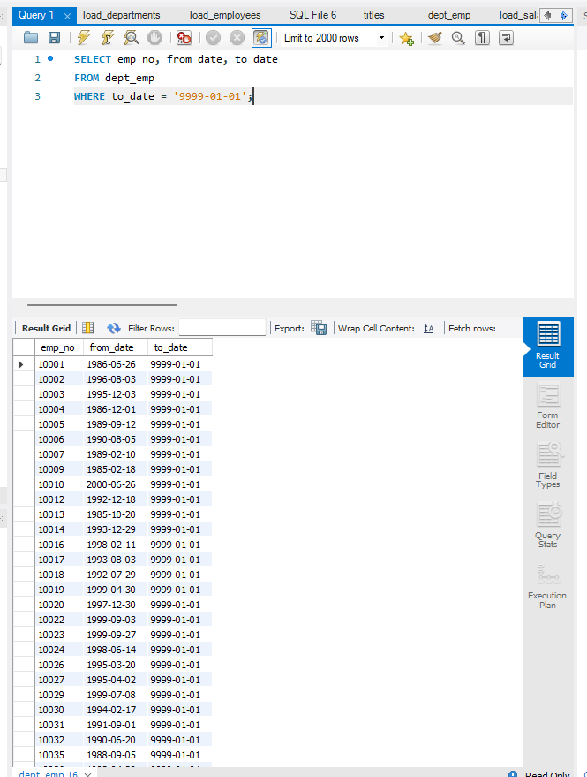
13. Create a trigger to print salary changes of employees. For example, if you enter an SQL statement such as UPDATE salaries SET salary = salary + 1000 WHERE emp no = 1500, the trigger should fire once for each row that is updated and it should print the new and old salaries, and the difference.
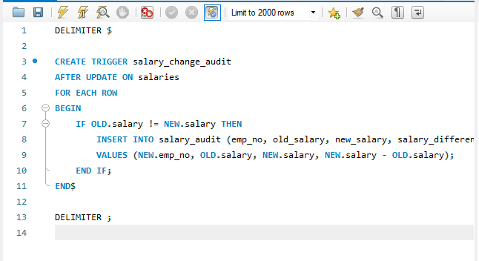
Test the trigger
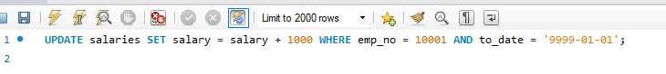

14. Create a trigger that will cause an error when an update occurs that would result in a salary increase greater than 10% of the current salary.
